SINGLE – posts relacionados a categoria

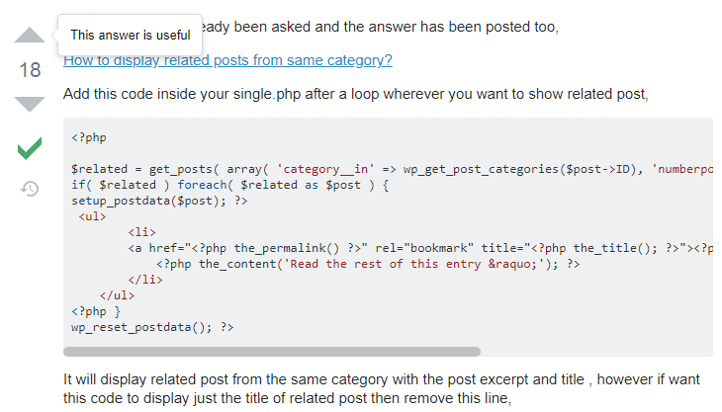

<?php

$related = get_posts( array( 'category__in' => wp_get_post_categories($post->ID), 'numberposts' => 5, 'post__not_in' => array($post->ID) ) );

if( $related ) foreach( $related as $post ) {

setup_postdata($post); ?>

<ul>

<li>

<a href="<?php the_permalink() ?>" rel="bookmark" title="<?php the_title(); ?>"><?php the_title(); ?></a>

<?php the_content('Read the rest of this entry &raquo;'); ?>

</li>

</ul>

<?php }

wp_reset_postdata(); ?>